COMSOL Multiphysics software

Modeling and simulation is now a reality for everyone thanks to COMSOL Multiphysics® version 5.1. The Application Builder and COMSOL Server™ have both been dramatically improved to enhance the simulation experience for you – and even for your colleagues who do not have a background in simulation. Furthermore, COMSOL Multiphysics and its add-on modules have also been improved. Browse through the release highlights to find out what is new or download COMSOL version 5.1 to utilize the latest technology in simulations today.

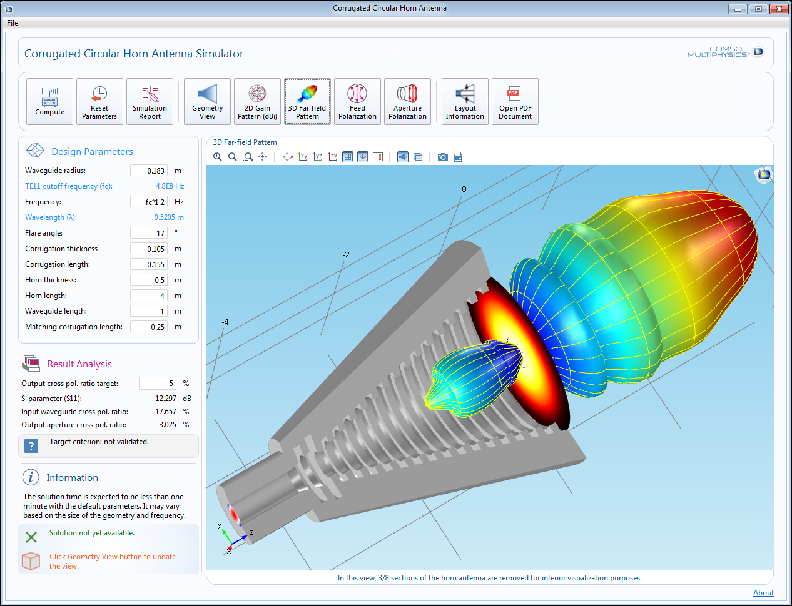

Zdroj: www.comsol.com

manual: http://www2.humusoft.cz/ftp/comsol/RS_uvod_do_CM/
http://www2.humusoft.cz/ftp/comsol/guides/

torrent: https://thepiratebay.vg/torrent/9618851/COMSOL_Multiphysics_4.4

